

Foundations of Programming

Assignment No.: 14
PROBLEM STATEMENT: Write a C program to input a binary number from the user and convert it into a decimal number.

OBJECTIVE:

- To understand number system conversions.
- To learn how to convert binary numbers to decimal numbers in C.
- To practice the use of loops and arithmetic operations.
- To develop logical thinking for number system problems.

THEORY:
A binary number system uses only two digits: 0 and 1. Each digit of a binary number represents a power of 2 depending on its position. To convert a binary number into its decimal equivalent, each digit is multiplied by 2 raised to the power of its position and the results are added together. In C programming, this conversion can be implemented using loops and arithmetic operations.

PLATFORM: Linux
ALGORITHM:
1: Start
2: Initiallize math.h and stdio.h library
3: Initiallize bin, count = 0, dec = 0
4: Read and input a binary number from user and store as bin.

5: While bin >0,
Initiallize digit as bin %10
dec + = digit* pow (2, count)
bin/=10
6: Display dec as decimal number

FLOWCHART:
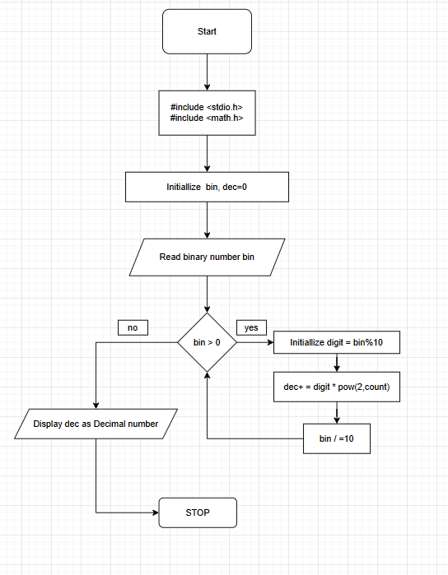
CODE:

#include <stdio.h>
#include <math.h>

int main() {
int bin,count=0,dec=0;

printf("Enter Binary number : ");
scanf("%d",&bin);

while(bin>0){
int digit;
digit=bin%10;

dec+=digit*pow(2,count);

bin/=10;
count++;
}

printf("Decimal Number : %d",dec);

return 0;
}

INPUT: Binary number entered by the user.

OUTPUT: Displays the decimal equivalent of the given binary number.
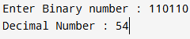

SAMPLE INPUT:
Enter a binary number: 1011

SAMPLE OUTPUT:
Decimal equivalent = 11
CONCLUSION: Thus, the C program successfully converts a binary number entered by the user into its decimal equivalent using loops and arithmetic operations.

FAQs:
- What is a binary number system?
- How is a binary number converted into a decimal number?
- What is the role of loops in binary to decimal conversion?
- What is the role of the pow() function in this program?
- What is the data type used to store binary and decimal numbers in this program?

